* **Title of the Seminar:** "AWARENESS PROGRAMME ON SOLAR POWER AND EMPLOYMENT OPPORTUNITIES ON IT"
* **Type of the Activity:** Seminar on Entrepreneurship
* **Organizing Department:** “CAREER COUNSELING CELL, CHAKDAHA COLLEGE AND NANDAN ALOY SOLAR POWER TRAINING”
* **Date of the Activity:** 06-04-2022
* **Number of participants:** 112
* **Speakers:** **Experts from Nandan Aloy Solar Power Training Company**
* **Objective of the Career Talk**: The objective of the awareness programme on solar power and employment opportunities is to educate students about the benefits and potential of solar energy as a renewable and sustainable power source
* **Outcome of the seminar:**
* Students learned about the various solar technologies available, including solar panels, solar water heaters, solar pumps, and solar-powered appliances
* The programme showcases the diverse employment opportunities in the solar energy sector, such as solar panel installation, maintenance, solar engineering, research, sales, and marketing
* **Relevant Web Link:** [**https://www.facebook.com/chakdahacollegeoffice/photos/a.116093593584612/487154713145163**](https://www.facebook.com/chakdahacollegeoffice/photos/a.116093593584612/487154713145163)

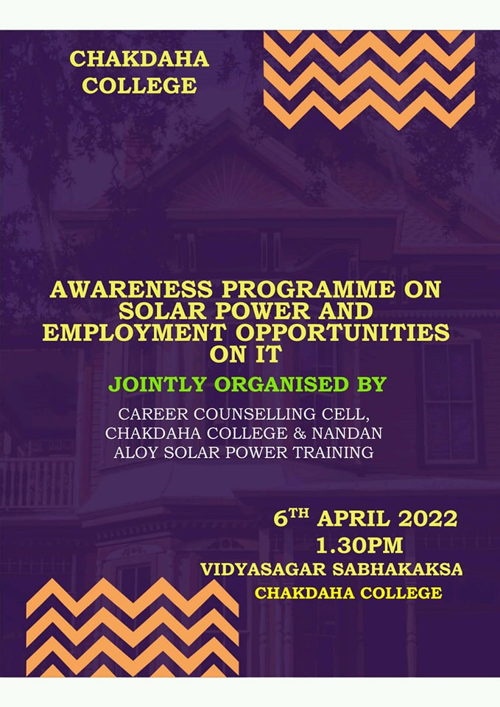

**Attendance Sheet**

